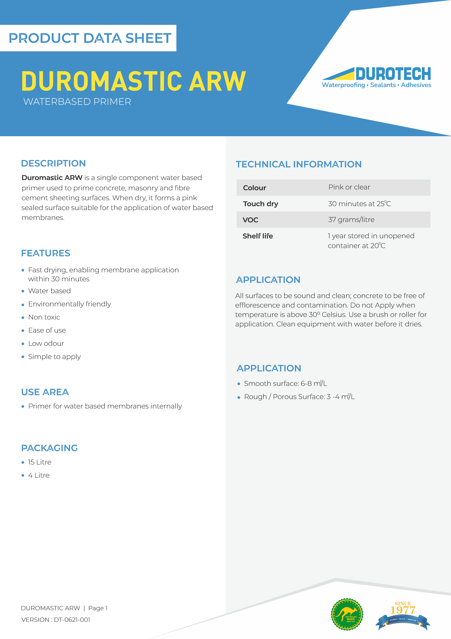

Do not use on glass or glazed surfaces.
Do
not
apply
over
curing
compounds,
wax/oily
surface, fibreglass,plastic or silicone treated surfaces.
Not
to
be
used
as
primer
for
areas
with
rising
moisture or negative hydrostatic pressure
Not
to
be
applied
over
raw
steel
or
metals
unless
otherwise specified in this data sheet.
Although
this
product
is
non
hazardous
and
water
based, contents should not be swallowed or inhaled.
In case of eye contamination, rinse with clean water
and seek medical advice.
Material Safety Data sheet (MSDS) available.
For
further
information
about
this
product
contact
technical department of Durotech Industries.
It is recommended before commencing the application;
that
adhesion
of
products
to
be
used
(
e.g.
primers,
membranes,
coatings
adhesives
etc)
is
tested
over
a
typical
area
of
the
prepared
surface
to
ensure
satisfactory
adhesion.
It
is
the
responsibility
of
the
applicator
to
carry
this
out
and
accept
the
substrate
suitability
before
any
application
starts.
Duromastic
Industries
offers
a
service
for
pre
testing
adhesion
to
surfaces
for
large
commercial
areas
or
unusual
substrates.
For
further
details
contact
Durotech
Industries.
Details contained in product data sheets are general. For
any situation or items not covered in this data sheet, it is
the
responsibility
of
the
applicator
to
check
with
Durotech
Technical
Services
before
commencing
the
application. A written confirmation will then be issued
by Durotech Technical Services.
Precautions
Notes
VERSION : DT-0621-001
DUROMASTIC ARW | Page 2
Durotech Industries
“This document, including any attached files, is strictly confidential and intended solely for the use of the individual or entity to which it is addressed. Durotech Industries prohibits the right to publish, copy,
distribute or disclose any information contained in this document, or its attachments, by any party other than the intended recipient. If you have received this document in error please notify the sender
anddelete it from your system no employee or agent is authorised to conclude any binding agreement or make any representation on behalf of Durotech Industries. The views or opinions presented in this
document are solely those of the author and do not necessarily represent those of Durotech Industries, except where the sender expressly, and with clear authority, states them to be the views of Durotech
Industries. Durotech Industries accepts no liability for any loss or damage (direct or indirect or consequential) arising from the use of or in connection with this document and any attachments and suggests
that the recipient check this document and any attached files for the presence of viruses."
sales@durotechindustries.com.au
34
Indian Drive Keysborough
Victoria 3173
Tel: 1300 434 272
VICTORIA
www.durotechindustries.com.au
14
Essex st, Minto, Sydney
NSW 2566

NEW SOUTH WALES
Tel: 1300 434 272
sales@durotechindustries.com.au
www.durotechindustries.com.au
Export Drive Molendinar,
16
Gold Coast 4214
QUEENSLAND
Tel: 1300 434 272
sales@durotechindustries.com.au
www.durotechindustries.com.au
348
Richmond Road
Netley Australia
SOUTH AUSTRALIA
Tel: 1300 434 272
sales@durotechindustries.com.au
www.durotechindustries.com.au

