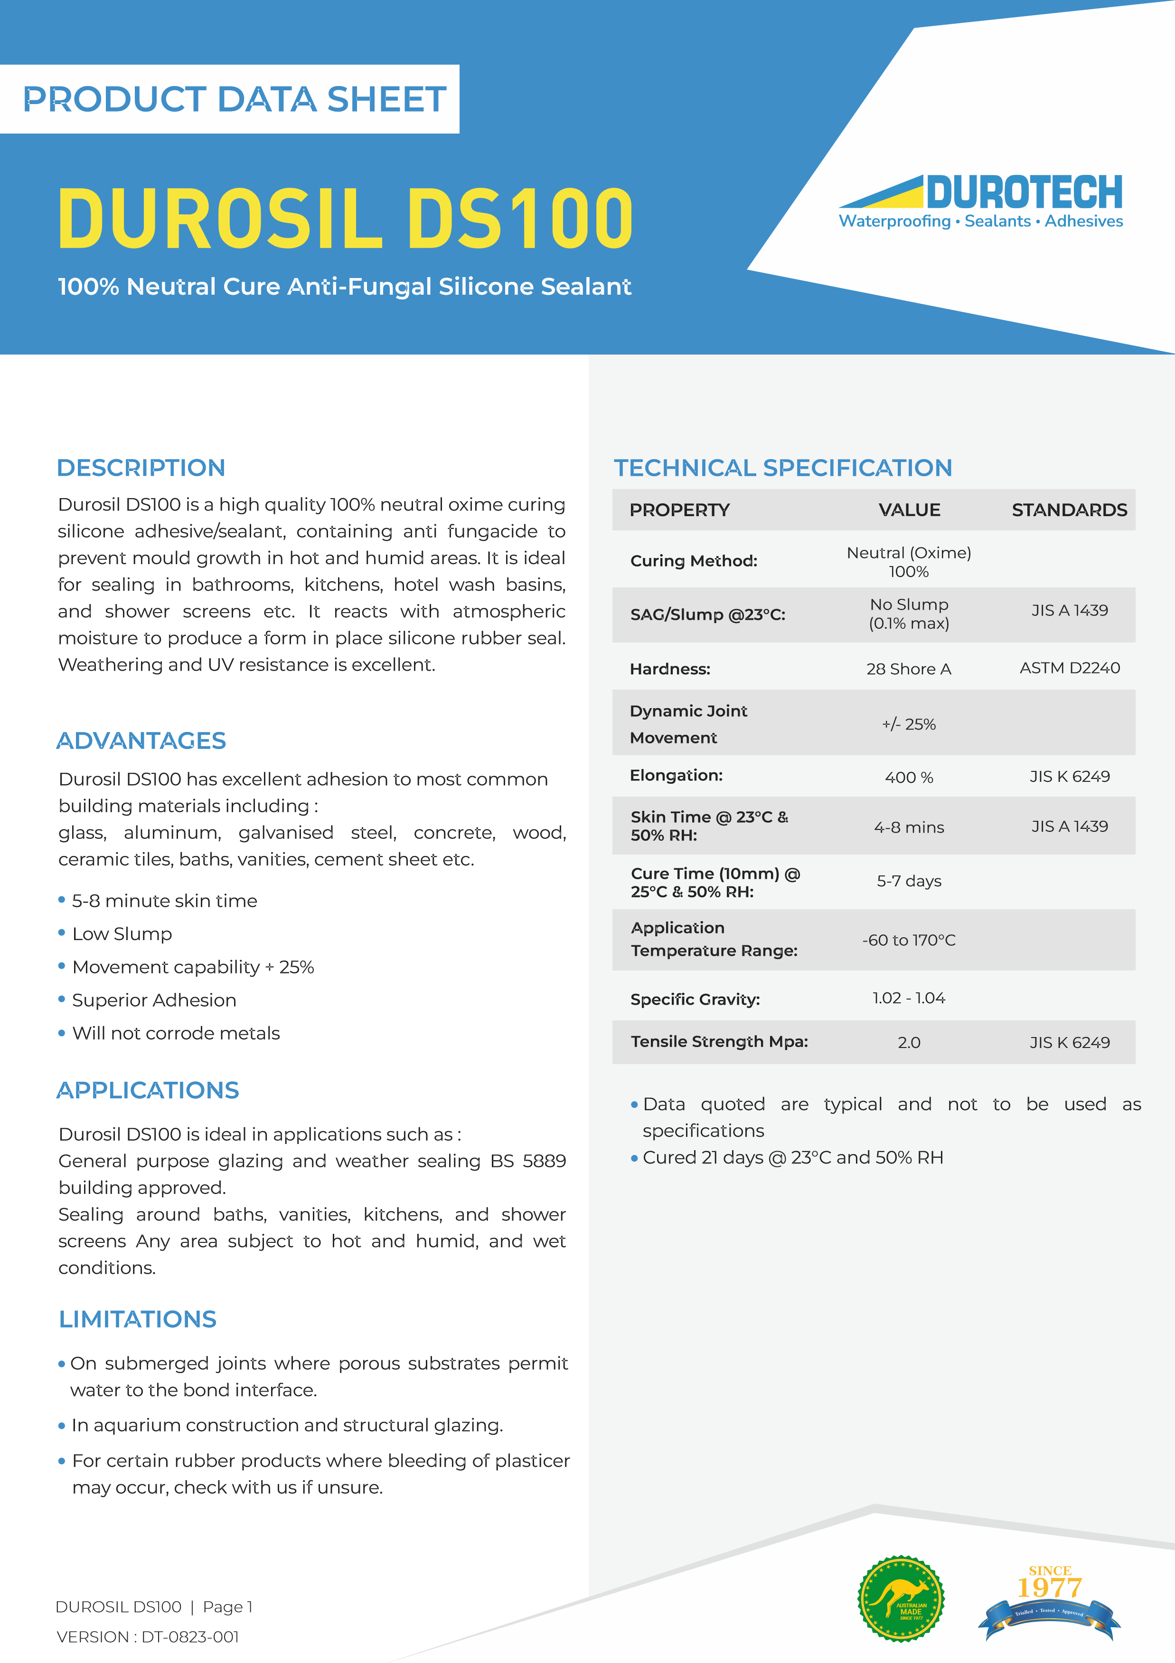

SURFACE PREPARATION
APPLICATION INSTRUCTIONS
PACKAGING
Colors
STORAGE
STORAGE
DUROSIL DS100 | Page 3
VERSION : DT-0823-001

All
surfaces
must
be
clean,
dry,
sound,
and
free
from
dust, oil, rust, or any other contamination.
Metals should be cleaned with a non-oily solvent soaked
clean cloth. Solvent should be wiped from the surface
with
a
clean
dry
cloth.
Use
an
alcohol
such
as
methylated
spirits
on
glass.
When
used
on
remedial
work all existing sealant must be removed.
Cut
nozzle
at
a
sharp
angle
slightly
wider
than
the
desired bead. Extrude sealant with a gun and tool with a
round spatula within 10 minutes to spread the sealant
against the joint surfaces.
Durosil DS100 is available in 300g Cartridges.

12
months
from
date
of
manufacture
if
stored
below
o
28
C
This product emits Methyl Ethyl Ketoxime whilst curing,
which
is
hazardous.
Use
in
well-ventilated
areas
and
avoid breathing vapors.
Contact with uncured product will irritate eyes.
In case of eye contact immediately flush with Water for
minutes and seek medical advice.
15
Avoid contact with skin or clothing.
Keep out of reach of children
Bluestone
Charcoal
Ivory
Light Grey
Mid Grey
Off White
Pewter
Stone Beige
Taupe
Tile Grey
Translucent
Travertine
White
Other
Durotech Industries
“This document, including any attached files, is strictly confidential and intended solely for the use of the individual or entity to which it is addressed. Durotech Industries prohibits the right to publish, copy,
distribute or disclose any information contained in this document, or its attachments, by any party other than the intended recipient. If you have received this document in error please notify the sender
anddelete it from your system no employee or agent is authorised to conclude any binding agreement or make any representation on behalf of Durotech Industries. The views or opinions presented in this
document are solely those of the author and do not necessarily represent those of Durotech Industries, except where the sender expressly, and with clear authority, states them to be the views of Durotech
Industries. Durotech Industries accepts no liability for any loss or damage (direct or indirect or consequential) arising from the use of or in connection with this document and any attachments and suggests
that the recipient check this document and any attached files for the presence of viruses."
sales@durotechindustries.com.au
34
Indian Drive Keysborough
Victoria 3173
Tel: 1300 434 272
VICTORIA
www.durotechindustries.com.au
Essex st, Minto, Sydney
14
NSW 2566

NEW SOUTH WALES
Tel: 1300 434 272
sales@durotechindustries.com.au
www.durotechindustries.com.au
Export Drive Molendinar,
16
Gold Coast 4214
QUEENSLAND
Tel: 1300 434 272
sales@durotechindustries.com.au
www.durotechindustries.com.au
348
Richmond Road
Netley Australia
SOUTH AUSTRALIA
Tel: 1300 434 272
sales@durotechindustries.com.au
www.durotechindustries.com.au

